Final

Static

Immutable

Private

1. can we make object as final

**You declare a reference as final and not the actual object**. That means, you cannot change the value of the reference

**final Keyword in Java**

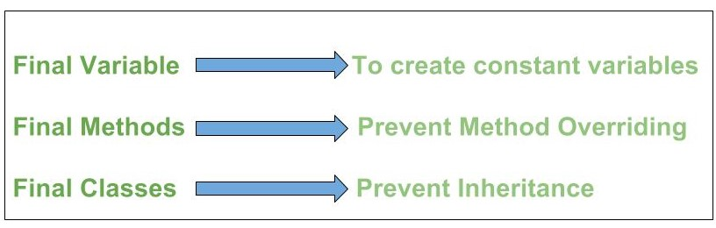

**Initializing a final Variable**   
We must initialize a final variable, otherwise, the compiler will throw a compile-time error. A final variable can only be initialized once, either via an [initializer](https://www.geeksforgeeks.org/g-fact-26-the-initializer-block-in-java/) or an assignment statement. There are three ways to initialize a final variable:

1. You can initialize a final variable when it is declared. This approach is the most common. A final variable is called a **blank final variable** if it is **not** initialized while declaration. Below are the two ways to initialize a blank final variable.
2. A blank final variable can be initialized inside an [instance-initializer block](https://www.geeksforgeeks.org/instance-initialization-block-iib-java/) or inside the constructor. If you have more than one constructor in your class then it must be initialized in all of them, otherwise, a compile-time error will be thrown.
3. A blank final static variable can be initialized inside a [static block](https://www.geeksforgeeks.org/g-fact-79/).

Basics

Design patterns

JVM

Data structures

Lambda

Java17 new features

Mongo DB